Analysis of Refinance Transition Behavior From Conventional 15
years Loan to Conventional 30 years Loan

Overview
We have discovered that when conventional 15-year borrowers need to refinance, over 90% of people will choose conventional 15-year loan or 30-year loan. To better model incentive for 15-year loans, we need to analysis the factors that could affect transition behaviors from 15-year loan to 30-year loan.

Data
To model transition behavior, we use the transition rate (‘Transit’) from 15-year loan to 30-year loan. The data is provided by Freddie Mac and is available quarterly from 2002-01-01 to 2017-12-01. The transition rate varies between 4.79% and 58.95%.

For the independent variables, we assume that 2 factors could have potential effect on transition behaviors.

- shape of yield curve, which we will model as the difference between 30-year mortgage rate and 15-year mortgage rate.

Diff = 30_Year_Mtg_Rate - 15_Year_Mtg_Rate

When the difference is higher, the yield curve is steeper, and 15-year borrowers will have less incentive to transit to 30-year loans. As a result, we believe ‘Diff’ factor could be negatively correlated with transition rate.

- Both 15 and 30 year mortgage rates are 1-point adjusted
- We use one-month lagged data
- Mortgage rates are calculated quarterly

- media effect (‘Media_Effect’). When the media effect is higher, 30-year mortgage rate is relatively lower, so 15-year borrowers will be more motivated to transit to 30-year loans. As a result, we believe ‘Media_Effect’ factor would be negatively correlated with transition rate.

We also use one-month lagged data and calculate quarterly average Media_Effect, corresponding to Transit data.

Regression Model
We first plot Transit against Diff and Media_Effect.
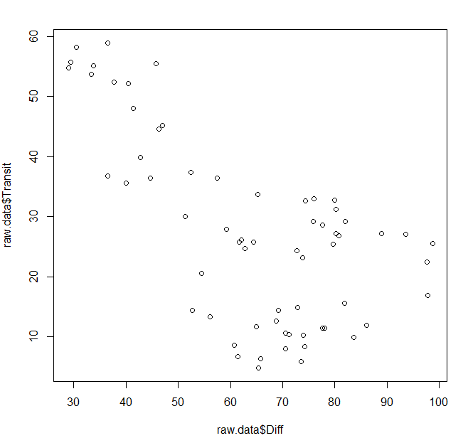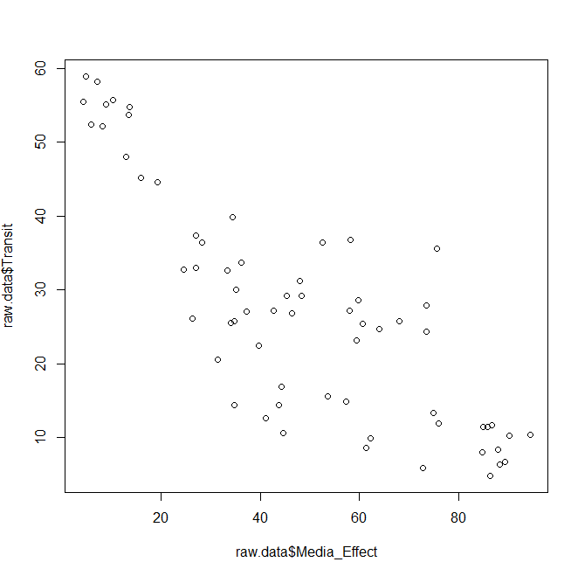
There’s some apparent negative correlation between Transit and 2 independent variables, which proves our assumption.

One-Factor simple regression

- Transit ~ Diff
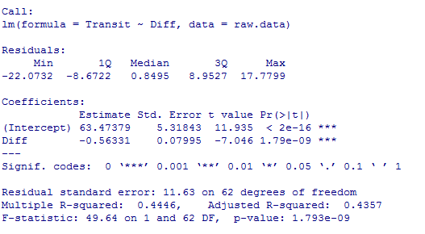
- Transit ~ Media_Effect
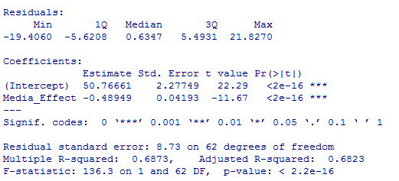

Two-Factor Regression

We then conduct the linear regression model:

Transit ~ Diff + Media_Effect

The results are:

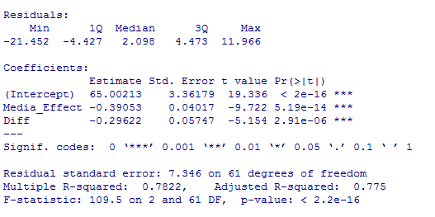

Both independent variables have significant negative effect on transit rate, and the Adjusted R-square of the model is 0.775.

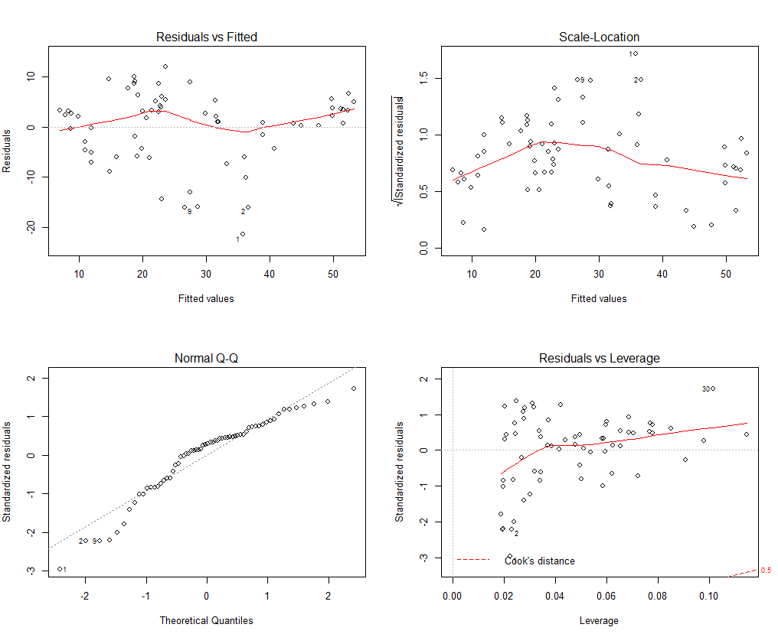

Structure coefficients

Correlation Yhat and Diff: -0.754, Correlation^2 = 0.569
Yhat and Media_Effect: -0.937, Correlation^2 = 0.878

Conclusion
We have proved that both the shape of yield curve and media effect have significant influence on transition behavior. Those two factors can explain 77.5% of the change in transition behaviors.

The coefficient between Diff and Media_Effect is 0.45, which shows weak evidence of multicollinearity.

The structure coefficients shows most of the variance in the model can be accounted to the media effect. Though Diff also shows a high impact on transit rate.

